Wuthering Heights

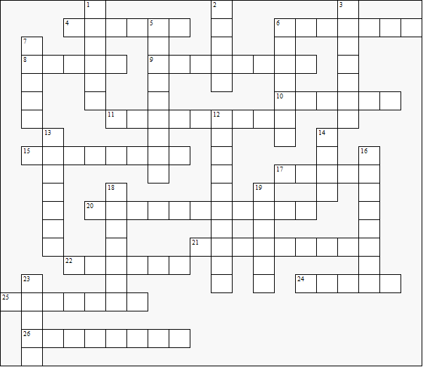

Across:  4 (See 20 across)  6 Catherine senior's father  8 Catherine junior's pony  9 The kind of countryside where the story is set  10 Heathcliff's son  10 Catherine junior's maiden name  11 The county where the story is set  15 Mr ......, The narrator  17 Penistone .......  20 and 4 across The narrator's residence  21 The city where Heathcliff was originally found  22 Heathcliff's housekeeper  24 Catherine junior's father's first name  25 Hindley's wife  26 Catherine senior's maiden name | Down:  1 The author's surname  2 ...... Cave  3 Mr ......, the doctor  5 The nearby village  6 Catherine senior's brother  7 The author's first name  12 Catherine junior's married name  13 The breed of Isabella's dogs  14 Mrs ......, the narrator's housekeeper  16 Edgar's sister  18 Isabella's dogs: Phœnix and ........  19 The old man at Wuthering Heights  23 Mr ......, the lawyer

Wuthering Heights – Solution

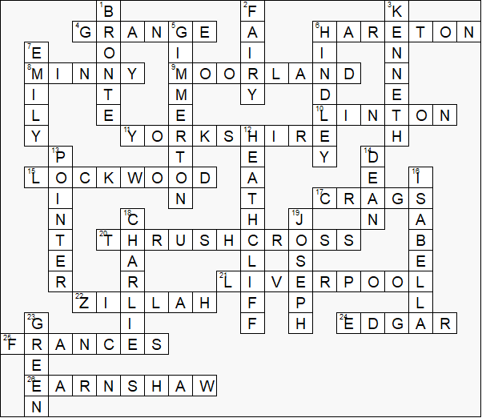

This worksheet was made up using TOOLBOX by Discovery Educational Software.

