Premier League

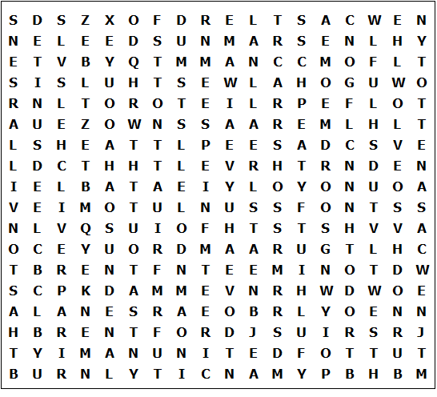

Arsenal | Burnley | Leeds United | Notts Forest
Aston Villa | Chelsea | Liverpool | Sunderland
Brentford | Crystal Palace | Man City | Tottenham
Bournemouth | Everton | Man United | West Ham
Brighton | Fulham | Newcastle | Wolves

Premier League – Solution

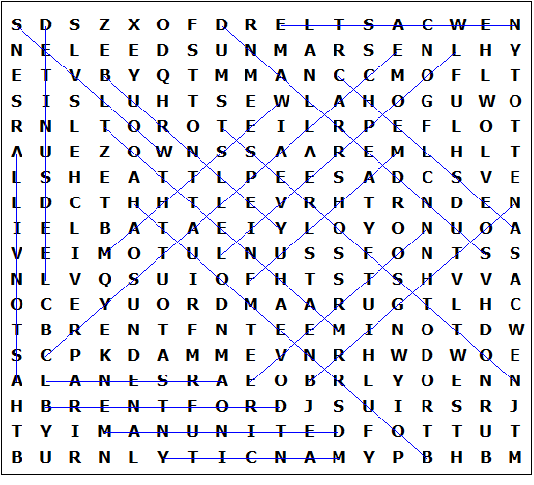

This worksheet was made up using TOOLBOX by Discovery Educational Software.

