NATO

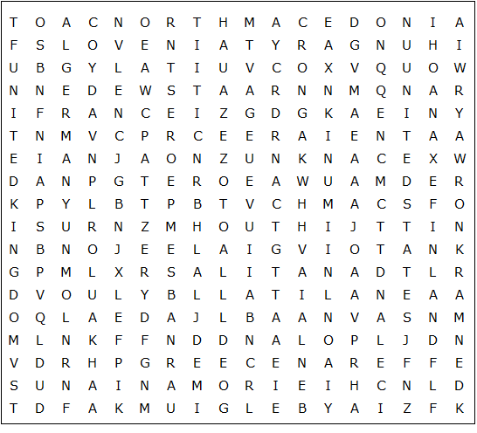

Albania Belgium Bulgaria Canada Croatia Czechia Denmark

Estonia Finland France Germany Greece Hungary Iceland

Italy Latvia Lithuania Luxembourg Montenegro Netherlands

North Macedonia Norway Poland Portugal Romania Slovakia

Slovenia Spain Sweden Turkey United Kingdom United States

NATO - Solution

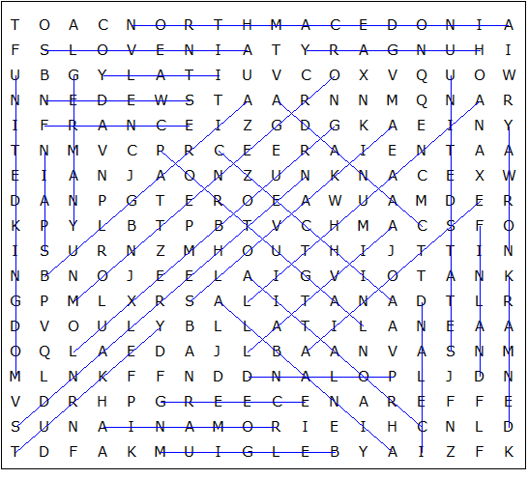

This puzzle was created in seconds using Toolbox, available for only £10 from discoveryeducationalsoftware.co.uk

