Far From The Madding Crowd

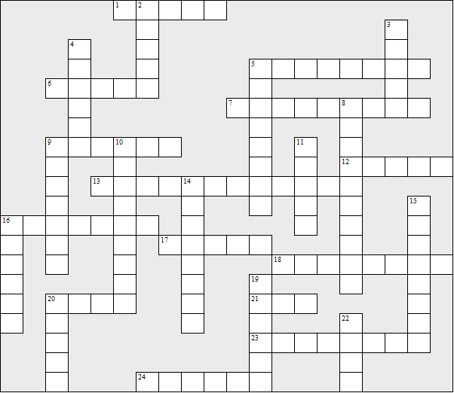

Across:  1 Mark's surname  5 Troy's army rank  6 Fanny's surname  7 Mr ........, the bailiff  9 The part of England where the story takes place  12 (See 16 down)  13 The market town  16 Mr ........, the parson  17 Troy's first name  18 Mr ........, the surgeon  20 Hennery's (Henry's) surname  21 Gabriel's surname  23 The feature on the church that caused a flood  24 Where Boldwood is at the end of the story | Down:  2 Susan Tall's husband  3 Maryann's surname  4 Gabriel's dog  5 Gabriel's occupation  8 The village near Bathsheba's farm  9 Boldwood's first name  10 Billy and Jacob's surname  11 Bathsheba's servant and confidente  14 Bathsheba's surname  15 Where Gabriel lives at the start of the story  16 (and 12 Across) The author  19 Jan's surname  20 The instrument Gabriel plays  22 Matthew's surname

Far From The Madding Crowd – Solution

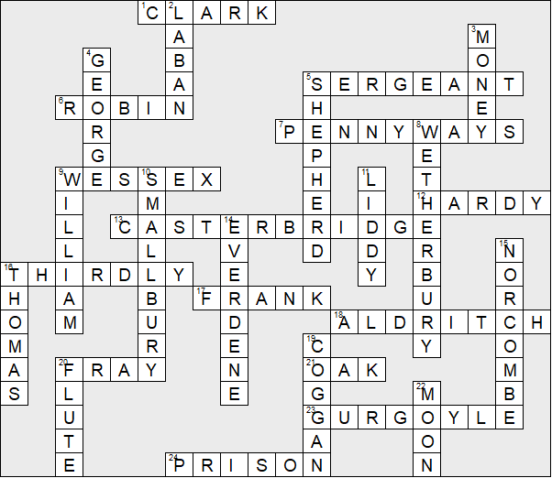

This worksheet was made up using TOOLBOX by Discovery Educational Software.

