The Lord of the Rings

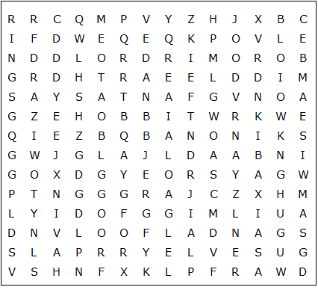

ARAGORN GANDALF BOROMIR GONDOR HOBBIT WIZARD
ELVES RINGS FRODO GIMLI DWARF LORD
MIDDLE EARTH PEREGRIN BAGGINS SAMWISE LEGOLAS FANTASY
The Lord of the Rings – Solution

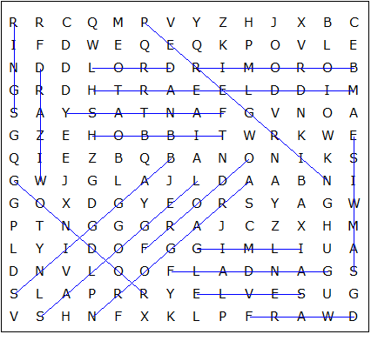

This worksheet was made up using TOOLBOX by Discovery Educational Software.

