The Prime Of Miss Jean Brodie

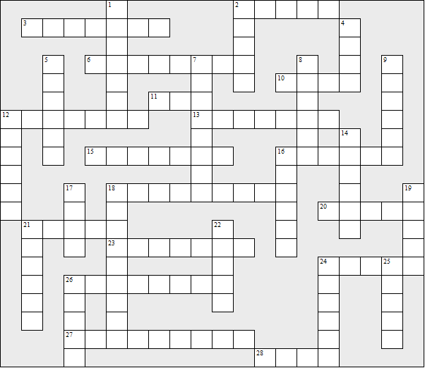

Across:  2 and 6 The girl who betrayed Miss Brodie  3 Where the singing teacher lives  6 See 2  10 and 18 The girl who died in a fire  11 See 16  12 The art teacher's wife  13 See 9 down  15 See 20  16, 5 down, 14 down, 11 and 21 The school  18 See 10  20, 24 and 15 The girl who died in Spain  21 See 16  23 See 28  24 See 20  26 Biggar, Melrose, Argyll and ?  27 The city where the story is set  28 and 23 The girl who posed for many  portraits | Down:  1 See 21  2 See 16  4 See 19  5 See 16 across  7 See 24  8 The type of hat the girls wore  9 and 13 acrross The girl who was good at maths  12 Eunice's husband's occupation  14 See 16 across  16 and 2 The author  17 The surname of the sewing teachers  18 The fascist leader Miss Brodie admired  19 ad 4 The girl who became an actress  21 and 1 The singing teacher  22 and 25 The art teacher  24 and 7 The girl who was good at sports  25 See 22  26 Sandy became Sister .....
The Prime Of Miss Jean Brodie – Solution

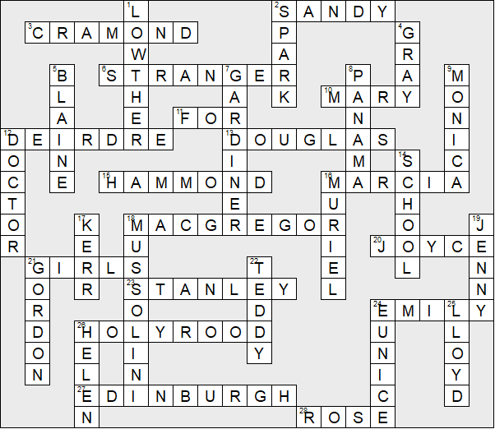

This worksheet was made up using TOOLBOX by Discovery Educational Software.

