The Hobbit

Find the 50 words below, then reading from top left use the unused letters to find eleven dwarves. Who’s missing?

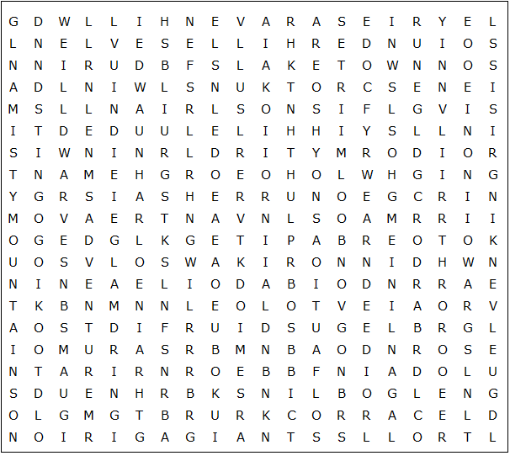

adventure | Durin | Girion | Oakenshield | spiders
Arkenstone | dwarves | Glamdring | Old Took | Sting
Bag-End | eagles | goblins | Orchrist | Thorin
Bard | Elrond | Gollum | orcs | Thrain
Beorn | Elvenking | Homely House | Ravenhill | Thror
Bilbo Baggins | elves | Iron Hills | Rivendell | trolls
Bolg | Esgaroth | Lake-Town | River Running | Underhill
carrock | eyries | Lonely Mountain | runes | wargs
Dain | Gandalf | Mirkwood | Smaug | Wilderland
Dale | giants | Misty Mountains | songs | wolves

The dwarves:

Not there:

The Hobbit - Solution

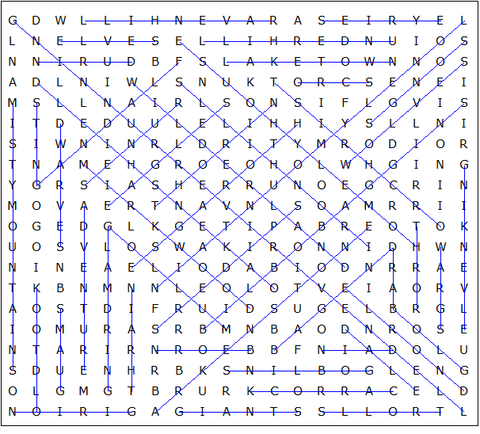

Hidde dwarves:

DWALIN, BALIN, KILI, FILI, DORI, NORI, ORI, GLOIN, BIFUR, BOFUR, BOMBUR

Not there: OIN (and THORIN who is in the main puzzle)

This puzzle was created in seconds using Toolbox, available for only £10 from discoveryeducationalsoftware.co.uk

