Harry Potter

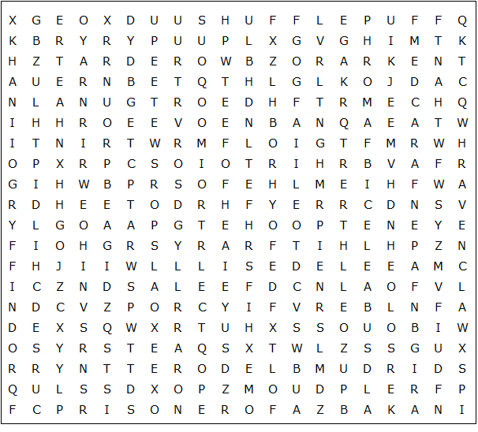

PRISONER OF AZBAKAN RAVENCLAW HALF-BLOOD PRINCE
POTTER HAGRID RUBEUS HARRY ALBUS VOLDEMORT
SORCERER'S STONE DEATHLY HALLOWS GOBLET OF FIRE GRANGER
ORDER OF THE PHEONIX CHAMBER OF SECRETS HOGWARTS
CURSED CHILD SLYTHERIN QUIDDITCH HERMIONE WEASLEY
DUMBLEDORE HIPPOGRIFF GRYFFINDOR HUFFLEPUFF
Harry Potter – Solution

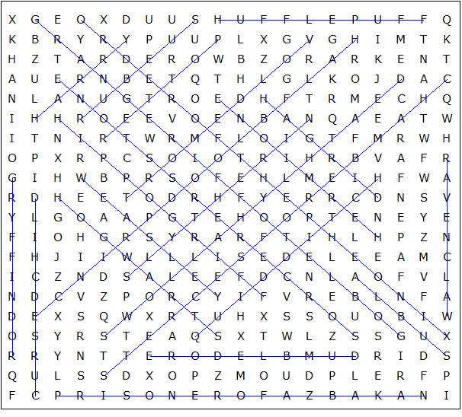

This worksheet was made up using TOOLBOX by Discovery Educational Software.

