The Great Gatsby

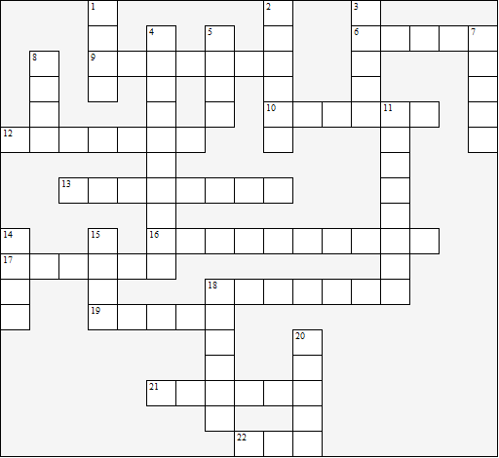

Across:  6 Myrtle lives in the Valley of  the .......  9 Where Tom lived previously  10 Who does George kill?  12 The village where Gatsby  lives  13 The narrator's surname  16 The part of New York where  the novel is set  17 Gatsby had studied at ......  University  18 Gatsby's house is a .......  19 Gatsby is in love with .......  21 Myrtle's surname  22 Gatsby's first name | Down:  1 The narrator's first name  2 Myrtle's husband  3 Gatsby's real first name  4 The author's surname  5 Gatsby's real surname  7 The author's first name  8 The narrator is a graduate of which  university?  11 Tom's surname  14 The sport Jordan Baker plays  15 The narrator is a ...... salesman  18 Tom's mistress  20 Gatsby's father
The Great Gatsby – Solution

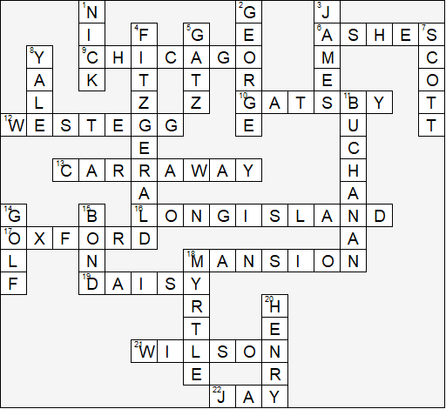

This worksheet was made up using TOOLBOX by Discovery Educational Software.

