EU Countries

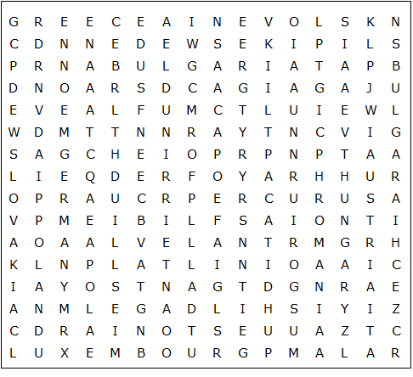

Austria Belgium Bulgaria Croatia Cyprus Czechia
Denmark Estonia Finland France Germany Greece
Hungary Ireland Italy Latvia Lithuania Luxembourg
Malta Netherlands Poland Portugal Romania Spain
Slovakia Slovenia Sweden
EU Countries – Solution

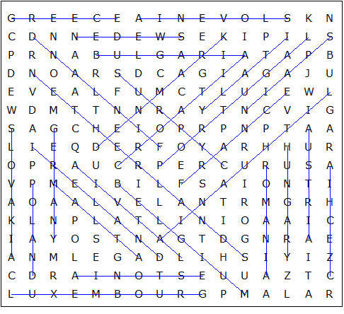

This worksheet was made up using TOOLBOX by Discovery Educational Software.

