EU Capitals

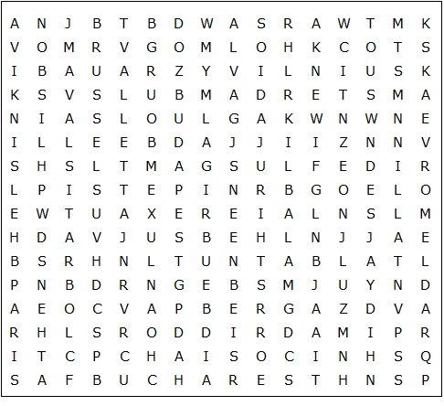

AMSTERDAM ATHENS BERLIN BRATISLAVA BRUSSELS
BUCHAREST BUDAPEST COPENHAGEN DUBLIN HELSINKI
LISBON LJUBLJANA LUXEMBOURG MADRID NICOSIA
PARIS PRAGUE RIGA ROME SOFIA STOCKHOLM
TALLINN VALLETTA VIENNA VILNIUS WARSAW
ZAGREB
EU Capitals – Solution

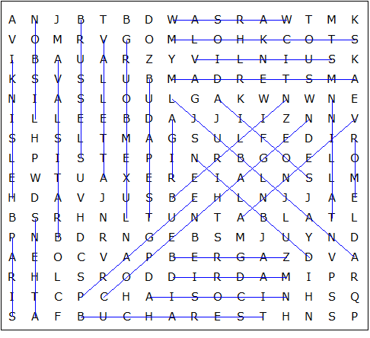

This worksheet was made up using TOOLBOX by Discovery Educational Software.

