The Crucible

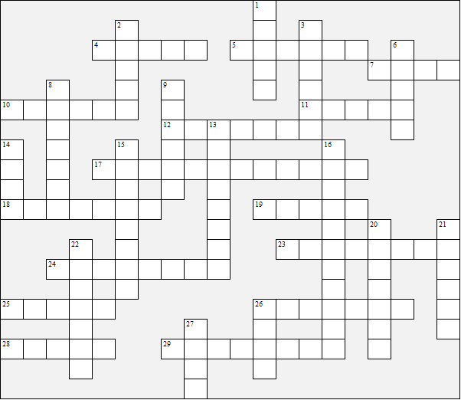

Across:  4 Parris' daughter  5 What Mrs Putman says Betty  was seen doing  7 Mr Proctor's first name  10 The Reverend Samuel .......  11 What Abigail is accused of  drinking  12 Mrs Nurse's first name  17 The author (both names)  18 The marshall  19 How many of Mrs Putman's  babies died?  23 The judge  24 Abigail's surname  25 and 2 Down the Putmans'  servant  26 Rebecca's husband  28 The town where the play is set  29 The Deputy Governor | Down:  1 Mr Corey's first name  2 (see25 Across)  3 Parris' slave  6 Short form of 'Goodwife' (Mrs)  8 Elizabeth's surname  9 Mrs Corey's first name  13 Parris previously lived in ......  14 The Putmans' daughter  15 The book title - The ........  16 The century the play is set in  20 The prison guard  21 The room where Act 3 is set  22 What people are accused of being  26 What was said to be in the soup  kettle  27 The Reverend John .....
The Crucible – Solution

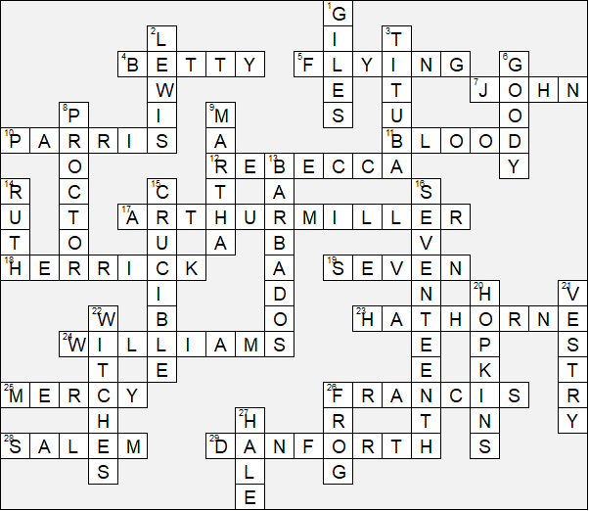

This worksheet was made up using TOOLBOX by Discovery Educational Software.

