English Counties – Instructions

There are 39 counties in England.

35 of these are listed to be found in the puzzle. Once these have all been found:

Starting top left and reading from left to right, pick out all letters that have not been used.

This will give the names of the four missing counties plus another place name.
English Counties

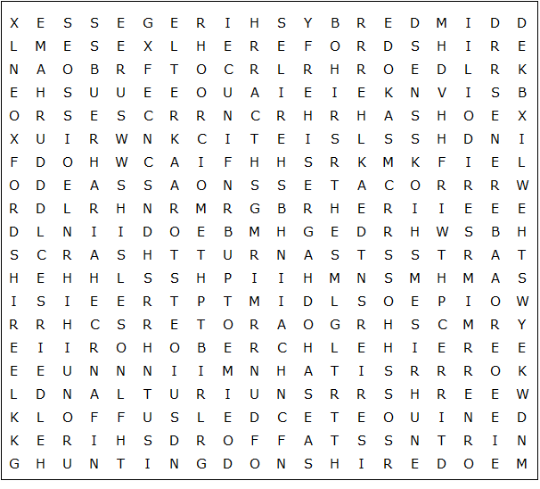

Northamptonshire Buckinghamshire Gloucestershire Huntingdonshire

Nottinghamshire Cambridgeshire Leicestershire Northumberland

Worcestershire Herefordshire Hertfordshire Staffordshire Essex

Bedfordshire Lincolnshire Warwickshire Oxfordshire Devon

Westmorland Cumberland Yorkshire Kent Surrey Durham

Derbyshire Lancashire Shropshire Berkshire Hampshire Dorset

Cheshire Cornwall Somerset Rutland Suffolk
English Counties – Solution

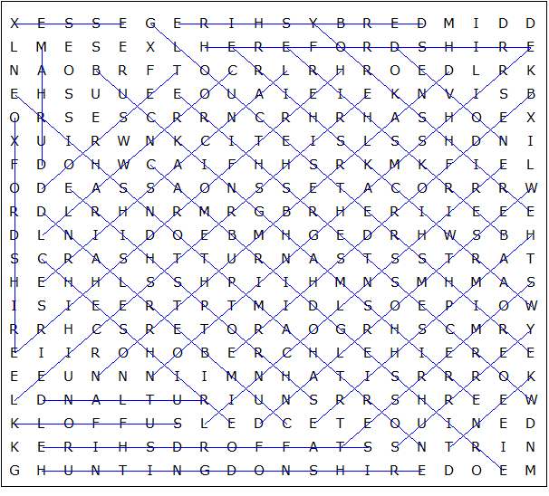

MIDDLESEX, NORFOLK, SUSSEX, WILTSHIRE, UNITED KINGDOM

This worksheet was made up using TOOLBOX by Discovery Educational Software.

