UK Cities - Pathfinder

Beginning with the letter in the square box, follow a continuous path to find 19 UK cities. The trail passes through each and every letter once and may twist up, down or sideways, but never diagonally.

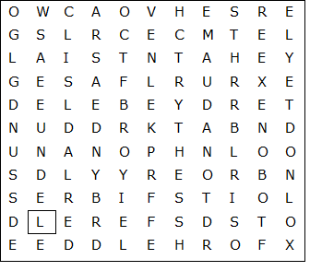

UK Cities - Pathfinder (solution)

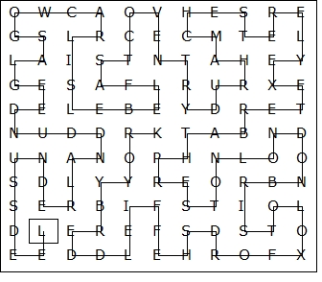

LEEDS – SUNDERLAND – DUNDEE – GLASGOW – CARLISLE – BELFAST
COVENTRY – DURHAM – CHESTER – ELY – EXETER – BATH – PRESTON
LONDON – BRISTOL – OXFORD – SHEFFIELD – DERBY - YORK

This worksheet was made up using TOOLBOX by Discovery Educational Software.

