What’s the capital of …..? (European Union)

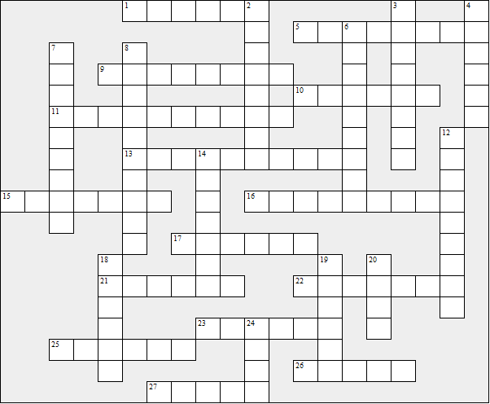

Across:  1 Croatia  5 Malta  9 Hungary  10 Ireland  11 Denmark  13 Slovakia  15 Lithuania  16 Romania  17 Portugal  21 Greece  22 Cyprus  23 Germany  25 Czechia  26 France  27 Bulgaria | Down:  2 Belgium  3 Finland  4 Spain  6 Slovenia  7 Sweden  8 Luxembourg  12 Netherlands  14 Estonia  18 Poland  19 Austria  20 Italy  24 Latvia
What’s the capital of …..? (European Union) – Solution

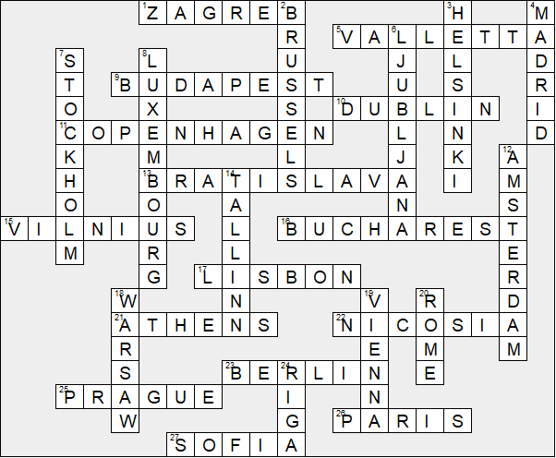

This worksheet was made up using TOOLBOX by Discovery Educational Software.

