Body

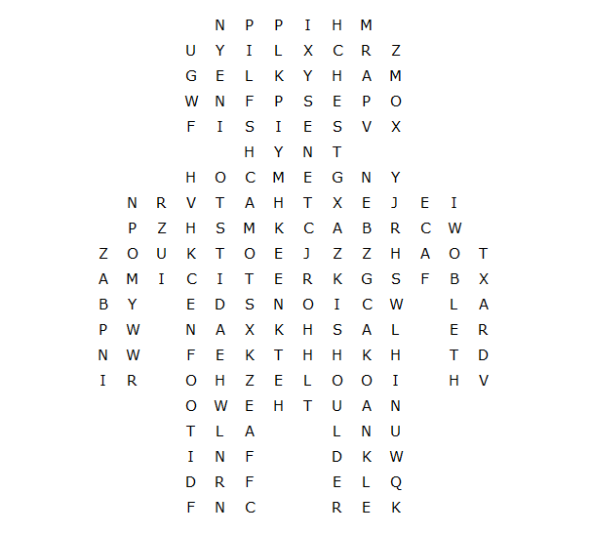

stomach finger ankle thumb chest foot hip
elbow thigh knee head face hair shoulder
hand heel neck skin back arm leg toe

Body – solution

